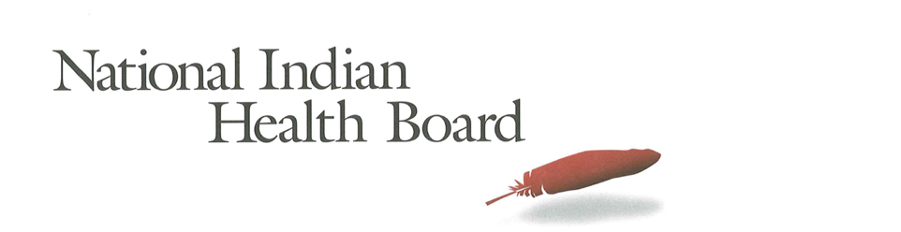

Iowa Medicaid Coverage for American Indians and Alaska Natives: The Impact of the affordable care act 2012-2016.
Tracking the Impact of Medicaid Coverage for American Indian and Alaska Natives

Table of Contents
Abstract 3
Methodology 3
Findings 3
Summary Table: Iowa 4
Medicaid Coverage 5
Medicaid Coverage of all American Indians and Alaska Natives 5
Medicaid Coverage for American Indians and Alaska Natives 6
with Access to IHS 6
Medicaid Coverage for American Indians and Alaska Natives 7
Without Access to IHS 7
Comparing Increases in Medicaid Coverage: By Access to IHS 8
Conclusion 8
2017 Report: Percentage of American Indian and Alaska Native Population with Medicaid Coverage, 30 States with Large American Indian and Alaska Native Pop. Ranked by 2016 9
2017 Report: Percentage of American Indian and Alaska Native Population Uninsured 2012 and 2016 in 30 States with Large Indian Populations, ranked by 2016 Percentage 10
The Percentage of Medicaid Enrollees with and without Access to IHS: Iowa 11

This project was supported by a Cooperative Agreement, Grant No. CMS-1MOCMS331623, from the U.S. Department of Health & Human Services, Centers for Medicare & Medicaid Services. The contents provided are solely the responsibility of the authors and do not necessarily represent the official views of HHS or any of its agencies.

Abstract

This data brief examines the evidence of the success of the Affordable Care Act to increase Medicaid Coverage for American Indians and Alaska Natives in Iowa. A review of findings from the American Community Survey depicts significant success in increasing the number enrolled in Medicaid. It also modest success for American Indians and Alaska Natives with access to IHS services and more significant success for those without access to IHS-funded health programs. The overall decrease in enrollment in Medicaid was 4,900 or 40% for all American Indians and Alaska Natives.

Methodology

The American Community Survey provides estimates of the number of insured, uninsured for American Indians and Alaska Natives (alone and in combination). The one-year survey provides estimates with low error rates at the national level of analysis. This analysis provides cross tabulations by sex and by access to IHS-funded health programs for the years 2012 and 2016. The analysis is built on the comparison between the two years to the two variables of sex and access to IHS.

Findings

Summary Table: Iowa
American Indian and Alaska Native Population 2012 and 2016
2012 | 2016
26,887 | 25,065
American Indian and Alaska Native Uninsured 2012 and 2016
2012 | 2016
4,486 | 2,619
Uninsured Rate 2012 and 2016
2012 | 2016
17% | 10%
Medicaid Enrollment 2012 and 2016
2012 | 2016
12,294 | 7,341

2012 to 2016 Medicaid Enrollment
Total American Indian and Alaska Native, With IHS and No IHS Access
Total Pop | 2012 | 2016 | Increase 12-16 | % increase
Total Pop | 12,294 | 7,341 | (4,953) | -40%
Male | 5,693 | 3,878 | (1,815) | -32%
Female | 6,601 | 3,463 | (3,138) | -48%
IHS | 2012 | 2016 | Increase 12-16
Total Pop | 380 | 888 | 508 | 134%
Male | 145 | 602 | 457 | 315%
Female | 235 | 286 | 51 | 22%
No IHS | 2012 | 2016 | Increase 12-16
Total Pop | 11,914 | 6,453 | (5,461) | -46%
Male | 5,548 | 3,276 | (2,272) | -41%
Female | 6,366 | 3,177 | (3,189) | -50%

Medicaid Coverage

Medicaid Coverage of all American Indians and Alaska Natives

The number of Iowa American Indians and Alaska Natives with Medicaid declined from 12,300 in 2012 to 7,300 in 2016. This 40% decrease of 4,900 Medicaid-covered American Indians and Alaska Natives is evidence of the impact of the decision not to expand Medicaid in Iowa. 29% of the total American Indian and Alaska Native population is covered by Medicaid in 2016 down from 46% in 2012. 26% of females, down from 49% in 2012, and 33% of males, down from 42% in 2012 were enrolled in Medicaid in 2016.

Medicaid Coverage for American Indians and Alaska Natives

with Access to IHS

The number of American Indians and Alaska Natives with access to IHS is too small for reliable estimates from the American Community Survey.

Medicaid Coverage for American Indians and Alaska Natives

Without Access to IHS

The ACS estimates that there were 11,900 Medicaid-enrolled American Indians and Alaska Natives without access to IHS-funded health programs in 2012. By 2016 this decreased by 5,400 to 6,400 an decrease of 46%. In 2012 52% of females had Medicaid coverage and that fell to 25% in 2016. Male coverage declined from 47% in 2012 to 30% in 2016. Overall, 27% of those without access to IHS were now covered by Medicaid health insurance in 2016, a comparatively low percentage for states with large Indian Populations.

Comparing Increases in Medicaid Coverage: By Access to IHS

American Indians and Alaska Natives with IHS access increased by 46 percentage points from 24% to 49%, but given the small number this estimate has a large error rate and caution is advised. Those who indicate they do not have access to IHS decreased by 22 percentage points from 49% to 27%.

Conclusion

Iowa joins a very few states with declines in enrollment in Medicaid of 4,900 or 40% for all American Indians and Alaska Natives. The uninsured rate for American Indians and Alaska Natives in Iowa declined from 17% to 10%, but Medicaid was not a part of this improvement in rates of insured and uninsured.

Source of Data: 1-year American Community Survey, US Census
Years: 2012 and 2016
No Foreign Born, that is, nativity is the United States.
American Indian and Alaska Natives Alone and In-combination with other races.

2017 Report: Percentage of American Indian and Alaska Native Population with Medicaid Coverage, 30 States with Large American Indian and Alaska Native Pop. Ranked by 2016

2017 Report: Percentage of American Indian and Alaska Native Population Uninsured 2012 and 2016 in 30 States with Large Indian Populations, ranked by 2016 Percentage

The Percentage of Medicaid Enrollees with and without Access to IHS: Iowa

