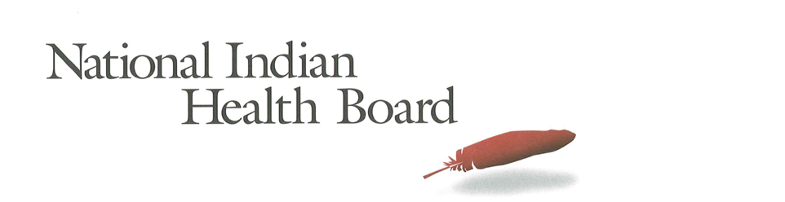

Kansas Medicaid Coverage for American Indians and Alaska Natives: The Impact of the affordable care act 2012-2016
Tracking the Impact of Medicaid Coverage for American Indian and Alaska Natives

Table of Contents
Abstract 3
Methodology 3
Findings 3
Summary Table: Kansas 4
Medicaid Coverage 5
Medicaid Coverage of all American Indians and Alaska Natives 5
Medicaid Coverage for American Indians and Alaska Natives 6
with Access to IHS 6
Medicaid Coverage for American Indians and Alaska Natives 7
Without Access to IHS 7
Comparing Decreases in Medicaid Coverage: By Access to IHS 8
Conclusion 8
2017 Report: Percentage of American Indian and Alaska Native Population with Medicaid Coverage, 30 States with Large American Indian and Alaska Native Pop. Ranked by 2016 9
2017 Report: Percentage of American Indian and Alaska Native Population Uninsured 2012 and 2016 in 30 States with Large Indian Populations, ranked by 2016 Percentage 10
The Percentage of Medicaid Enrollees with and without Access to IHS: Kansas 11

This project was supported by a Cooperative Agreement, Grant No. CMS-1MOCMS331623, from the U.S. Department of Health & Human Services, Centers for Medicare & Medicaid Services. The contents provided are solely the responsibility of the authors and do not necessarily represent the official views of HHS or any of its agencies.

Abstract

This data brief examines the evidence of the success of the Affordable Care Act to decrease Medicaid Coverage for American Indians and Alaska Natives in Kansas. A review of findings from the American Community Survey depicts significant success in increasing the number enrolled in Medicaid. It also depicts success for American Indians and Alaska Natives with or without access to IHS-funded health programs. Kansas’s overall decrease in enrollment in Medicaid was 3,800 or 23% from 2012 to 2016. A decrease in population accounts for some of the decline, but the decision not to expand Medicaid is the reason the state did not enjoy the increases experienced in nearly every other state---even those states that did not expand Medicaid.

Methodology

The American Community Survey provides estimates of the number of insured, uninsured for American Indians and Alaska Natives (alone and in combination). The one-year survey provides estimates with low error rates at the national level of analysis. This analysis provides cross tabulations by sex and by access to IHS-funded health programs for the years 2012 and 2016. The analysis is built on the comparison between the two years to the two variables of sex and access to IHS.

Findings

Summary Table: Kansas
American Indian and Alaska Native Population 2012 and 2016
2012 | 2016
59,514 | 56,595
American Indian and Alaska Native Uninsured 2012 and 2016
2012 | 2016
11,538 | 7,436
Uninsured Rate 2012 and 2016
2012 | 2016
19% | 13%
Medicaid Enrollment 2012 and 2016
2012 | 2016
16,426 | 12,573

2012 to 2016 Medicaid Enrollment
Total American Indian and Alaska Native, With IHS and No IHS Access
Total Pop | 2012 | 2016 | Decrease 12-16 | % decrease
Total Pop | 16,426 | 12,573 | (3,853) | -23%
Male | 8,395 | 6,361 | (2,034) | -24%
Female | 8,031 | 6,212 | (1,819) | -23%
IHS | 2012 | 2016 | Decrease 12-16
Total Pop | 1,734 | 1,421 | (313) | -18%
Male | 876 | 941 | 65 | 7%
Female | 858 | 480 | (378) | -44%
No IHS | 2012 | 2016 | Decrease 12-16
Total Pop | 14,692 | 11,152 | (3,540) | -24%
Male | 7,519 | 5,420 | (2,099) | -28%
Female | 7,173 | 5,732 | (1,441) | -20%

Medicaid Coverage

Medicaid Coverage of all American Indians and Alaska Natives

The number of Kansas American Indians and Alaska Natives with Medicaid declined from 16,400 in 2012 to 12,573 in 2016. This 23% decrease of 3,800 Medicaid-covered American Indians and Alaska Natives is evidence of the challenges facing Medicaid coverage in Kansas. 22% of the total American Indian and Alaska Native population is covered by Medicaid in 2016 down from 28% in 2012. 21% of females and 23% of males were enrolled in Medicaid in 2016 making Kansas one of the lowest in the nation in terms of percentage of American Indian and Alaska Native enrolled in Medicaid.

Medicaid Coverage for American Indians and Alaska Natives

with Access to IHS

The number of American Indians and Alaska Natives enrolled in Medicaid in Kansas with access to IHS decreased by 300 from 1,700 in 2012 to 1,400 in 2016. In 2016, 22% of males with access to IHS had Medicaid coverage compared to 19% in 2012 while female coverage decreased from 15% to 13%. These are very low participation percentages, unmatched in all but a very few states.

Medicaid Coverage for American Indians and Alaska Natives

Without Access to IHS

The ACS estimates that there were 14,600 Medicaid-enrolled American Indians and Alaska Natives without access to IHS-funded health programs in 2012. By 2016 this decreased by 3,500 a decrease of 24%. In 2012, 28% of females had Medicaid coverage and that decreased to 23% in 2016. Male coverage decreased from 32% to 23%. Overall, 23% of those without access to IHS were now covered by Medicaid health insurance in 2016 a 7-percentage point decline since 2012.

Comparing Decreases in Medicaid Coverage: By Access to IHS

American Indians and Alaska Natives with IHS access saw little change from 2012 to 2016. Those who indicate they do not have access to IHS saw Medicaid decrease by 7 percentage points from 30% to 23%.

Conclusion

Kansas’s overall decrease in enrollment in Medicaid was 3,800 or 23% from 2012 to 2016. A decrease in population accounts for some of the decline, but the decision not to expand Medicaid is the reason the state did not enjoy the increases experienced in nearly every other state---even those states that did not expand Medicaid. The state’s uninsured rate did decline over these years from 19% to 13% a finding that deserves further examination.

Source of Data: 1-year American Community Survey, US Census
Years: 2012 and 2016
No Foreign Born, that is, nativity is the United States.
American Indian and Alaska Natives Alone and In-combination with other races.

2017 Report: Percentage of American Indian and Alaska Native Population with Medicaid Coverage, 30 States with Large American Indian and Alaska Native Pop. Ranked by 2016

2017 Report: Percentage of American Indian and Alaska Native Population Uninsured 2012 and 2016 in 30 States with Large Indian Populations, ranked by 2016 Percentage

The Percentage of Medicaid Enrollees with and without Access to IHS: Kansas

