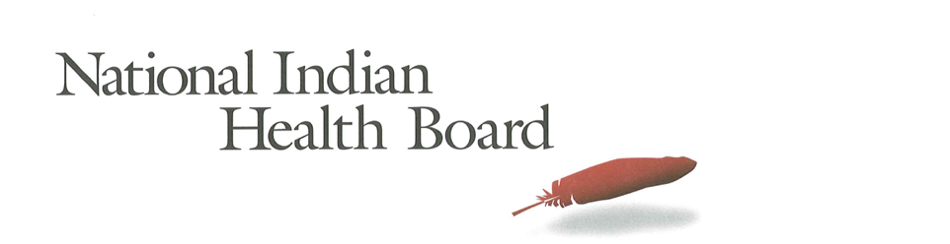

Louisiana Medicaid Coverage for American Indians and Alaska Natives: The Impact of the affordable care act 2012-2016.
Tracking the Impact of Medicaid Coverage for American Indian and Alaska Natives

Table of Contents
Abstract 3
Methodology 3
Findings 3
Summary Table: Louisiana 4
Medicaid Coverage 5
Medicaid Coverage of all American Indians and Alaska Natives 5
Medicaid Coverage for American Indians and Alaska Natives 6
with Access to IHS 6
Medicaid Coverage for American Indians and Alaska Natives 7
Without Access to IHS 7
Comparing Increases in Medicaid Coverage: By Access to IHS 8
Conclusion 8
2017 Report: Percentage of American Indian and Alaska Native Population with Medicaid Coverage, 30 States with Large American Indian and Alaska Native Pop. Ranked by 2016 9
2017 Report: Percentage of American Indian and Alaska Native Population Uninsured 2012 and 2016 in 30 States with Large Indian Populations, ranked by 2016 Percentage 10
The Percentage of Medicaid Enrollees with and without Access to IHS: Louisiana 11

This project was supported by a Cooperative Agreement, Grant No. CMS-1MOCMS331623, from the U.S. Department of Health & Human Services, Centers for Medicare & Medicaid Services. The contents provided are solely the responsibility of the authors and do not necessarily represent the official views of HHS or any of its agencies.

Abstract

This data brief examines the evidence of the success of the Affordable Care Act to increase Medicaid Coverage for American Indians and Alaska Natives in Louisiana. A review of findings from the American Community Survey depicts significant success in increasing the number enrolled in Medicaid. The overall increase in enrollment in Medicaid was 7,600 or 55% for all American Indians and Alaska Natives. In a state with just 3% of the total Medicaid population having access to IHS-funded health care services, it is not surprising that most of the gains in coverage were for those American Indians and Alaska Natives without access to Indian Health Service-funded programs. Medicaid expansion succeeded in increasing health insurance coverage and lowering the rate of uninsured from 21% to 15%.

Methodology

The American Community Survey provides estimates of the number of insured, uninsured for American Indians and Alaska Natives (alone and in combination). The one-year survey provides estimates with low error rates at the national level of analysis. This analysis provides cross tabulations by sex and by access to IHS-funded health programs for the years 2012 and 2016. The analysis is built on the comparison between the two years to the two variables of sex and access to IHS.

Findings

Summary Table: Louisiana

American Indian and Alaska Native Population 2012 and 2016
2012 | 2016
52,216 | 58,923
American Indian and Alaska Native Uninsured 2012 and 2016
2012 | 2016
11,072 | 8,573
Uninsured Rate 2012 and 2016
2012 | 2016
21% | 15%
Medicaid Enrollment 2012 and 2016
2012 | 2016
13,766 | 21,370

2012 to 2016 Medicaid Enrollment
Total American Indian and Alaska Native, With IHS and No IHS Access
Total Pop | 2012 | 2016 | Increase 12-16 | % increase
Total Pop | 13,766 | 21,370 | 7,604 | 55%
Male | 5,870 | 8,600 | 2,730 | 47%
Female | 7,896 | 12,770 | 4,874 | 62%
IHS | 2012 | 2016 | Increase 12-16
Total Pop | 441 | 724 | 283 | 64%
Male | 298 | 201 | (97) | -33%
Female | 143 | 523 | 380 | 266%
No IHS | 2012 | 2016 | Increase 12-16
Total Pop | 13,325 | 20,646 | 7,321 | 55%
Male | 5,572 | 8,399 | 2,827 | 51%
Female | 7,753 | 12,247 | 4,494 | 58%

Medicaid Coverage

Medicaid Coverage of all American Indians and Alaska Natives

The number of Louisiana American Indians and Alaska Natives with Medicaid rose from 13,700 in 2012 to nearly 21,300 in 2016. This 55% increase of 7,600 newly Medicaid-covered American Indians and Alaska Natives is evidence of the success of Medicaid expansion in Louisiana. 36% of the total American Indian and Alaska Native population is covered by Medicaid in 2016 up from 26% in 2012. 41% of females and 31% of males were enrolled in Medicaid in 2016, both up by over 10 percentage points since 2012.

Medicaid Coverage for American Indians and Alaska Natives

with Access to IHS

The number of American Indians and Alaska Natives enrolled in Medicaid in Louisiana with access to IHS is too small for reliable estimates from the American Community Survey.

\

Medicaid Coverage for American Indians and Alaska Natives

Without Access to IHS

The ACS estimates that there were 13,300 Medicaid-enrolled American Indians and Alaska Natives without access to IHS-funded health programs in 2012. By 2016 this increased by 7,300 to 20,600 an increase of 55%. In 2012, 31% of females had Medicaid coverage and that increased to 42% in 2016. Male coverage increased to 31% from 21% in 2012. Overall, 37% of those without access to IHS were now covered by Medicaid health insurance in 2016.

Comparing Increases in Medicaid Coverage: By Access to IHS

American Indians and Alaska Natives who indicate they do not have access to IHS increased by 11 percentage points from 26% to 37%.

Conclusion

In Louisiana, the overall increase in enrollment in Medicaid was 7,600 or 55% for all American Indians and Alaska Natives. In a state with just 3% of the total Medicaid population having access to IHS-funded health care services, it is not surprising that most of the gains in coverage were for those American Indians and Alaska Natives without access to Indian Health Service-funded programs. Medicaid expansion was successful in increasing coverage at a rate higher than the national average. This means increased access to health care services for an American Indian and Alaska Native population without the option of many IHS-funded health programs in the state. Medicaid expansion also succeeded, in part, in lowering the rate of uninsured from 21% to 15%. There are still gains can be made to lower that rate further.

Source of Data: 1-year American Community Survey, US Census
Years: 2012 and 2016
No Foreign Born, that is, nativity is the United States.
American Indian and Alaska Natives Alone and In-combination with other races.

2017 Report: Percentage of American Indian and Alaska Native Population with Medicaid Coverage, 30 States with Large American Indian and Alaska Native Pop. Ranked by 2016

2017 Report: Percentage of American Indian and Alaska Native Population Uninsured 2012 and 2016 in 30 States with Large Indian Populations, ranked by 2016 Percentage

The Percentage of Medicaid Enrollees with and without Access to IHS: Louisiana

