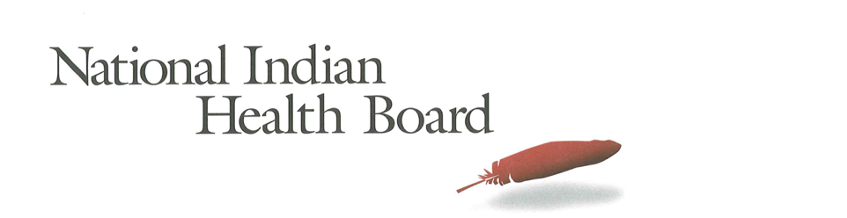

Montana Medicaid Coverage for American Indians and Alaska Natives: The Impact of the affordable care act 2012-2016.
Tracking the Impact of the Medicaid Coverage for American Indian and Alaska Natives

Table of Contents
Abstract 3
Methodology 3
Findings 3
Summary Tables: Montana 4
Medicaid Coverage 5
Medicaid Coverage of all American Indians and Alaska Natives 5
Medicaid Coverage for American Indians and Alaska Natives 6
with Access to IHS 6
Medicaid Coverage for American Indians and Alaska Natives Without Access to IHS 7
Comparing Increases in Medicaid Coverage: Access to IHS 8
Conclusion 9
2017 Report: Percentage of American Indian and Alaska Native Population with Medicaid Coverage, 30 States with Large American Indian and Alaska Native Pop. Ranked by 2016 10
2017 Report: Percentage of American Indian and Alaska Native Population Uninsured 2012 and 2016 in 30 States with Large Indian Populations, ranked by 2016 Percentage 11
The Percentage of Medicaid Enrollees with and without Access to IHS 12

This project was supported by a Cooperative Agreement, Grant No. CMS-1MOCMS331623, from the U.S. Department of Health & Human Services, Centers for Medicare & Medicaid Services. The contents provided are solely the responsibility of the authors and do not necessarily represent the official views of HHS or any of its agencies.

Abstract

This data brief examines the evidence of the success of the Affordable Care Act to increase Medicaid Coverage for American Indians and Alaska Natives in Montana. A review of findings from the American Community Survey depicts recent success in increasing the number enrolled in Medicaid. It also depicts variation for American Indians and Alaska Natives with or without access to IHS-funded health programs. The overall increase in Medicaid was 27% for all American Indians and Alaska Natives. Female enrollment increased by 8% and Males increased by 55%. Montana implemented Medicaid expansion in September of 2016 and the positive results of that expansion have reached the state’s large Indian population of nearly 90,000.

Methodology

The American Community Survey provides estimates of the number of insured, uninsured for American Indians and Alaska Natives (alone and in combination). The one-year survey provides estimates with low error rates at the national level of analysis. This analysis provides cross tabulations by sex and by access to IHS-funded health programs for the years 2012 and 2016. The analysis is built on the comparison between the two years to the two variables of sex and access to IHS.

Findings

Summary Tables: Montana
American Indian and Alaska Native Population 2012 and 2016
2012 | 2016
85,517 | 89,645
American Indian and Alaska Native Uninsured 2012 and 2016
2012 | 2016
31,019 | 18,908
Uninsured Rate 2012 and 2016
2012 | 2016
36% | 21%
Medicaid Enrollment 2012 and 2016
2012 | 2016
31,656 | 40,102

2012 to 2016 Medicaid Enrollment
Total American Indian and Alaska Native, With IHS and No IHS Access
Total Pop | 2012 | 2016 | Increase 12-16 | % increase
Total Pop | 31,656 | 40,102 | 8,446 | 27%
Male | 12,581 | 19,559 | 6,978 | 55%
Female | 19,075 | 20,543 | 1,468 | 8%
IHS | 2012 | 2016 | Increase 12-16
Total Pop | 17,798 | 21,821 | 4,023 | 23%
Male | 8,882 | 9,541 | 659 | 7%
Female | 8,916 | 12,280 | 3,364 | 38%
No IHS | 2012 | 2016 | Increase 12-16
Total Pop | 13,858 | 18,281 | 4,423 | 32%
Male | 3,699 | 10,018 | 6,319 | 171%
Female | 10,159 | 8,263 | (1,896) | -19%

Medicaid Coverage

Medicaid Coverage of all American Indians and Alaska Natives

The number of American Indians and Alaska Natives with Medicaid rose from 31,600 in 2012 to 40,102 in 2016. This 27% increase of 8,400 newly Medicaid covered American Indians and Alaska Natives is the early evidence of the success of Medicaid expansion in Montana. 46% of females and 43% of males were enrolled in Medicaid in 2016 and 45% of the total American Indian and Alaska Native population.

Medicaid Coverage for American Indians and Alaska Natives

with Access to IHS

The number of American Indians and Alaska Natives enrolled in Medicaid in Montana with access to IHS increased by 4,000 from 17,200 in 2012 to 21,800 in 2016. Female enrollment increased 38%, far more than males who had only a 7% increase. It is likely that there is still some reluctance to enroll on Montana’s reservations; a reluctance perhaps stronger among males. 40% of those with access to IHS now have Medicaid, up from 32% in 2012, with 43% of females and 37% of males reporting Medicaid coverage in 2016.

Medicaid Coverage for American Indians and Alaska Natives Without Access to IHS

The ACS estimates that there were 13,800 Medicaid enrolled American Indians and Alaska Natives without access to IHS-funded health programs in 2012. By 2016 this increased by 4,400 to 13,800 an increase of 32%. Inexplicably, Males’ enrollment increased, more than doubled, while females decreased---the opposite of the pattern for those with access to IHS. 51% of males now have Medicaid coverage, up from 29% in 2012, while females declined from 62% to 53%.

Comparing Increases in Medicaid Coverage: Access to IHS

Both populations, those with access to IHS and those without access to IHS-funded health care services made impressive gains in Medicaid coverage from 2012 to 2016. Those with IHS access increased by 8 percentage points from 32% to 40%, and those who indicate they do not have access to IHS increased 5 percentage points from 47% to 52%. The gains in Medicaid coverage were experienced by all American Indians and Alaska Natives in the state.

Conclusion

The September 2016 adoption of Medicaid expansion is starting to bear fruit in Montana. 8,400 are newly enrolled, a 27% increase over 2012. Males enrollment increased by 55% a stunningly successful achievement and one that promises increased revenues to the State’s IHS funded health programs, including iHS, Tribal and Urban Health Programs. Although the rate of uninsured declined from its 36% 2012 level there is still 21% of the population uninsured with many newly eligible for Medicaid.

Source of Data: 1-year American Community Survey, US Census
Years: 2012 and 2016
No Foreign Born, that is, nativity is the United States.
American Indian and Alaska Natives Alone and In-combination with other races.

2017 Report: Percentage of American Indian and Alaska Native Population with Medicaid Coverage, 30 States with Large American Indian and Alaska Native Pop. Ranked by 2016

2017 Report: Percentage of American Indian and Alaska Native Population Uninsured 2012 and 2016 in 30 States with Large Indian Populations, ranked by 2016 Percentage

The Percentage of Medicaid Enrollees with and without Access to IHS

