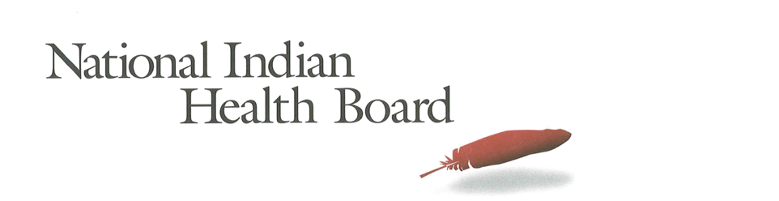

Oklahoma Medicaid Coverage for American Indians and Alaska Natives: The Impact of the affordable care act 2012-2016.
Tracking the Impact of Medicaid Coverage for American Indian and Alaska Natives

Table of Contents
Abstract 3
Methodology 3
Findings 3
Summary Table: Oklahoma 4
Medicaid Coverage 5
Medicaid Coverage of all American Indians and Alaska Natives 5
Medicaid Coverage for American Indians and Alaska Natives 6
With Access to IHS 6
Medicaid Coverage for American Indians and Alaska Natives 7
Without Access to IHS 7
Comparing Increases in Medicaid Coverage: By Access to IHS 8
Conclusion 8
2017 Report: Percentage of American Indian and Alaska Native Population with Medicaid Coverage, 30 States with Large American Indian and Alaska Native Pop. Ranked by 2016 10
2017 Report: Percentage of American Indian and Alaska Native Population Uninsured 2012 and 2016 in 30 States with Large Indian Populations, ranked by 2016 Percentage 11
The Percentage of Medicaid Enrollees with and without Access to IHS: Oklahoma 12

This project was supported by a Cooperative Agreement, Grant No. CMS-1MOCMS331623, from the U.S. Department of Health & Human Services, Centers for Medicare & Medicaid Services. The contents provided are solely the responsibility of the authors and do not necessarily represent the official views of HHS or any of its agencies.

Abstract

This data brief examines the evidence of the success of the Affordable Care Act to increase Medicaid Coverage for American Indians and Alaska Natives in Oklahoma. A review of findings from the American Community Survey depicts little evidence of success in increasing the number enrolled in Medicaid. The overall decrease in enrollment in Medicaid was or 1% for all American Indians and Alaska Natives. Enrollment increases were larger for American Indians and Alaska Natives with access to IHS as those with access increased by 9% compared to the 14% decrease for those without access to IHS. The decision not to expand Medicaid is the most likely reason the rate of uninsured remained at 25% in 2016, one of the highest in the nation.

Methodology

The American Community Survey provides estimates of the number of insured, uninsured for American Indians and Alaska Natives (alone and in combination). The one-year survey provides estimates with low error rates at the national level of analysis. This analysis provides cross tabulations by sex and by access to IHS-funded health programs for the years 2012 and 2016. The analysis is built on the comparison between the two years to the two variables of sex and access to IHS.

Findings

Summary Table: Oklahoma
American Indian and Alaska Native Population 2012 and 2016
2012 | 2016
510,587 | 522,442
American Indian and Alaska Native Uninsured 2012 and 2016
2012 | 2016
144,713 | 129,643
Uninsured Rate 2012 and 2016
2012 | 2016
28% | 25%
Medicaid Enrollment 2012 and 2016
2012 | 2016
125,126 | 124,331

2012 to 2016 Medicaid Enrollment
Total American Indian and Alaska Native, With IHS and No IHS Access
Total Pop | 2012 | 2016 | Increase 12-16 | % increase
Total Pop | 125,126 | 124,331 | (795) | -1%
Male | 59,550 | 56,917 | (2,633) | -4%
Female | 65,576 | 67,414 | 1,838 | 3%
IHS | 2012 | 2016 | Increase 12-16
Total Pop | 70,399 | 77,078 | 6,679 | 9%
Male | 32,297 | 34,721 | 2,424 | 8%
Female | 38,102 | 42,357 | 4,255 | 11%
No IHS | 2012 | 2016 | Increase 12-16
Total Pop | 54,727 | 47,253 | (7,474) | -14%
Male | 27,253 | 22,196 | (5,057) | -19%
Female | 27,474 | 25,057 | (2,417) | -9%

Medicaid Coverage

Medicaid Coverage of all American Indians and Alaska Natives

The number of Oklahoma American Indians and Alaska Natives with Medicaid declined from 125,100 in 2012 to 124,300 in 2016. This 1% decrease (statistically no change) is evidence of the decision not to expand Medicaid in Oklahoma. 24% of the total American Indian and Alaska Native population is covered by Medicaid in 2016 essentially unchanged from 25% in 2012. 26% of females and 22% of males were enrolled in Medicaid Coverage; the lowest enrollment rates in the nation for any state with a significant Indian population.

Medicaid Coverage for American Indians and Alaska Natives

With Access to IHS

The number of American Indians and Alaska Natives enrolled in Medicaid in Oklahoma with access to IHS increased by 6,600 or 9% from 70,400 in 2012 to 77,000 in 2016. Female enrollment was up by 11% and males 8% over 2012. Overall 23% of those with access to IHS were now covered by Medicaid health insurance in 2016 unchanged from 2012. In 2016, 21% of males with access to IHS had Medicaid coverage compared to 22% in 2012 while female coverage was essentially unchanged from 24% to 25% in 2016.

Medicaid Coverage for American Indians and Alaska Natives

Without Access to IHS

The ACS estimates that there were 54,700 Medicaid-enrolled American Indians and Alaska Natives without access to IHS-funded health programs in 2012. By 2016 this decreased by 7,400 to 47,200 a decrease of 14%. In 2012, 28% of females had Medicaid coverage and that decreased to 27% in 2016. Male coverage decreased from 27% to 23%. Overall, 25% of those without access to IHS were now covered by Medicaid health insurance in 2016, down slightly from 2012.

Comparing Increases in Medicaid Coverage: By Access to IHS

American Indians and Alaska Natives with IHS access enrollment was unchanged from 2012 to 2016. Those who indicate they do not have access to IHS decreased by 2 percentage points from 27% to 25%.

Conclusion

Oklahoma’s decision not to expand Medicaid resulted in an overall decrease in enrollment in Medicaid of 1% for all American Indians and Alaska Natives despite a 12,000 person increase in population from 2012 to 2016. Enrollment increases were larger for American Indians and Alaska Natives with access to IHS as those with access increased by 9% compared to the 14% decrease for those without access to IHS. The uninsured rate in the state did decline from 28% in 2012 to 25% in 2012 despite the limited contribution of Medicaid to increasing coverage in the state. The 25% rate is one of the highest in the nation and many would likely be eligible for Medicaid should the state decide to expand Medicaid in the future.

Source of Data: 1-year American Community Survey, US Census
Years: 2012 and 2016
No Foreign Born, that is, nativity is the United States.
American Indian and Alaska Natives Alone and In-combination with other races.

2017 Report: Percentage of American Indian and Alaska Native Population with Medicaid Coverage, 30 States with Large American Indian and Alaska Native Pop. Ranked by 2016

2017 Report: Percentage of American Indian and Alaska Native Population Uninsured 2012 and 2016 in 30 States with Large Indian Populations, ranked by 2016 Percentage

The Percentage of Medicaid Enrollees with and without Access to IHS: Oklahoma

