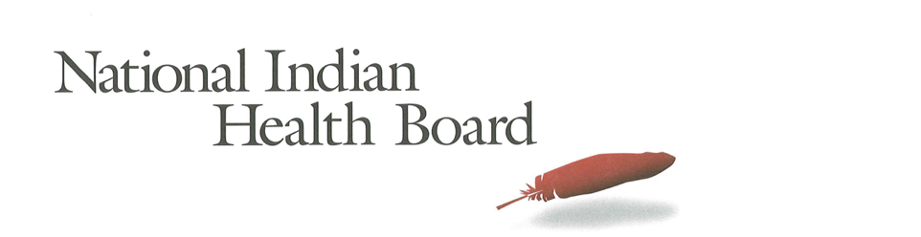

Rhode Island Medicaid Coverage for American Indians and Alaska Natives: The Impact of the affordable care act 2012-2016.
Tracking the Impact of Medicaid Coverage for American Indian and Alaska Natives

Table of Contents
Abstract 3
Methodology 3
Findings 3
Summary Table: Rhode Island 4
Medicaid Coverage 5
Medicaid Coverage of all American Indians and Alaska Natives 5
Medicaid Coverage for American Indians and Alaska Natives 6
with Access to IHS 6
Medicaid Coverage for American Indians and Alaska Natives 7
Without Access to IHS 7
Comparing Increases in Medicaid Coverage: By Access to IHS 8
Conclusion 8
2017 Report: Percentage of American Indian and Alaska Native Population with Medicaid Coverage, 30 States with Large American Indian and Alaska Native Pop. Ranked by 2016 9
2017 Report: Percentage of American Indian and Alaska Native Population Uninsured 2012 and 2016 in 30 States with Large Indian Populations, ranked by 2016 Percentage 10
The Percentage of Medicaid Enrollees with and without Access to IHS: Rhode Island 11

This project was supported by a Cooperative Agreement, Grant No. CMS-1MOCMS331623, from the U.S. Department of Health & Human Services, Centers for Medicare & Medicaid Services. The contents provided are solely the responsibility of the authors and do not necessarily represent the official views of HHS or any of its agencies.

Abstract

This data brief examines the evidence of the success of the Affordable Care Act to increase Medicaid Coverage for American Indians and Alaska Natives in Rhode Island. A review of findings from the American Community Survey depicts significant success in increasing the number enrolled in Medicaid. Rhode Island uninsured rate was 6% in 2016, one of the lowest in the nation, down from 9% in 2012. In a state with a rapidly increasing American Indian and Alaska Native population, from 10,300 in 2012 to 14,800 in 2016, Medicaid increased its enrollment by 45%; keeping pace with the state’s rapid population growth.

Methodology

The American Community Survey provides estimates of the number of insured, uninsured for American Indians and Alaska Natives (alone and in combination). The one-year survey provides estimates with low error rates at the national level of analysis. This analysis provides cross tabulations by sex and by access to IHS-funded health programs for the years 2012 and 2016. The analysis is built on the comparison between the two years to the two variables of sex and access to IHS.

Findings

Summary Table: Rhode Island
American Indian and Alaska Native Population 2012 and 2016
2012 | 2016
10,394 | 14,879
American Indian and Alaska Native Uninsured 2012 and 2016
2012 | 2016
900 | 951
Uninsured Rate 2012 and 2016
2012 | 2016
9% | 6%
Medicaid Enrollment 2012 and 2016
2012 | 2016
4,811 | 6,971

2012 to 2016 Medicaid Enrollment
Total American Indian and Alaska Native, With IHS and No IHS Access
Total Pop | 2012 | 2016 | Increase 12-16 | % increase
Total Pop | 4,811 | 6,971 | 2,160 | 45%
Male | 2,273 | 3,790 | 1,517 | 67%
Female | 2,538 | 3,181 | 643 | 25%
IHS | 2012 | 2016 | Increase 12-16
Total Pop | 50 | - | (50) | -100%
Male | - | - | - | #DIV/0!
Female | 50 | - | (50) | -100%
No IHS | 2012 | 2016 | Increase 12-16
Total Pop | 4,761 | 6,971 | 2,210 | 46%
Male | 2,273 | 3,790 | 1,517 | 67%
Female | 2,488 | 3,181 | 693 | 28%

Medicaid Coverage

Medicaid Coverage of all American Indians and Alaska Natives

The number of Rhode Island American Indians and Alaska Natives with Medicaid rose from 4,800 in 2012 to 6,900 in 2016. This 45% increase of 2,100 newly Medicaid-covered American Indians and Alaska Natives is in response to population growth in the state and Medicaid expansion. 47% of the total American Indian and Alaska Native population is covered by Medicaid in 2016 up from 46% in 2012. 43% of females and 51% of males were enrolled in Medicaid in 2016, the highest rate of Medicaid participation for males in the nation.

Medicaid Coverage for American Indians and Alaska Natives

with Access to IHS

The number of American Indians and Alaska Natives enrolled in Medicaid in Rhode Island with access to IHS is too small for reliable estimates due to the small population.

Medicaid Coverage for American Indians and Alaska Natives

Without Access to IHS

The ACS estimates that there were 4,700 Medicaid-enrolled American Indians and Alaska Natives without access to IHS-funded health programs in 2012. By 2016 this increased by 2,200 to 6,900 an increase of 46%. In 2012, 45% of females had Medicaid coverage and that remained statistically unchanged at 44% in 2016. Male coverage increased from 50% to 51%, also within the margin of error. Overall, 47% of those without access to IHS were now covered by Medicaid health insurance in 2016.

Comparing Increases in Medicaid Coverage: By Access to IHS

American Indians and Alaska Natives with IHS access was too small for reliable estimates from the American Community Survey. Those who indicate they do not have access to IHS and have Medicaid coverage grew by 45%, but was unchanged as a percentage of the population with no access to IHS.

Conclusion

Rhode Island’s overall increase in enrollment in Medicaid depicts significant success in increasing the number enrolled in Medicaid. Rhode Island’s uninsured rate was 6% in 2016, one of the lowest in the nation, down from 9% in 2012. In a state with a rapidly increasing American Indian and Alaska Native population, from 10,300 in 2012 to 14,800 in 2016, Medicaid increased its enrollment by 45%; keeping pace with the state’s rapid population growth.

Source of Data: 1-year American Community Survey, US Census
Years: 2012 and 2016
No Foreign Born, that is, nativity is the United States.
American Indian and Alaska Natives Alone and In-combination with other races.

2017 Report: Percentage of American Indian and Alaska Native Population with Medicaid Coverage, 30 States with Large American Indian and Alaska Native Pop. Ranked by 2016

2017 Report: Percentage of American Indian and Alaska Native Population Uninsured 2012 and 2016 in 30 States with Large Indian Populations, ranked by 2016 Percentage

The Percentage of Medicaid Enrollees with and without Access to IHS: Rhode Island

