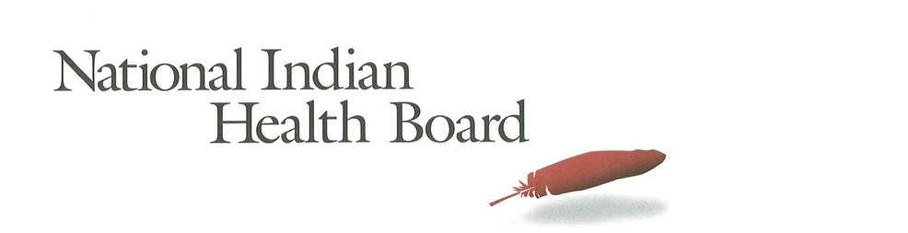

Alabama

Insurance, Uninsured, and Medicaid: American Indians and Alaska Natives, 2012 and 2017.

This project was supported by a Cooperative Agreement, Grant No. CMS-1MOCMS331623, from the U.S. Department of Health & Human Services, Centers for Medicare & Medicaid Services. The contents provided are solely the responsibility of the authors and do not necessarily represent the official views of HHS or any of its agencies.

Alabama
Summary Tables: | Alabama
American Indian and Alaska Native Population 2012 and 2017
2012 | 2017
54,455 | 52,132
American Indian and Alaska Native Uninsured 2012 and 2017
2012 | 2017
10,402 | 6,196
Uninsured Rate 2012 and 2017
2012 | 2017
19% | 12%
Medicaid Enrollment 2012 and 2017
2012 | 2017
14,565 | 11,308
Percent with Medicaid 2012 and 2017
2012 | 2017
27% | 22%
Abstract

This report uses the 2012 to 2017 estimates of the American Community Survey (ACS) to track insurance coverage for American Indians and Alaska Natives (AI/ANs) including uninsurance rates and Medicaid enrollment. From 2012 to 2017 AI/ANs experienced large decreases in the number uninsured, decreases in the uninsurance rate, and increases in health insurance coverage, particularly Medicaid coverage (enrollment gains).

Alabama had a 2017 AI/AN Population of 52,000 with 6,200 uninsured and an uninsurance rate of 12%. 2017 Medicaid enrollment was an estimated 11,000—about 3,000 less than 2012. Alabama saw Medicaid coverage decrease from 27% of the AI/AN population in 2012 to 22% in 2017.

Research Note: The American Community Survey (ACS) Coverage Question.

The ACS health insurance question asks the respondent to give a separate answer for each member of the household regarding health insurance coverage. The respondent may choose more than one of the answers to the question about what type of coverage they have.
- Employer Sponsored Insurance (ESI)
- Private, paid by individual also known as “non-Group” coverage
- Medicare
- Medicaid
- Tricare, Health care insurance for military and families
- VA, Veteran’s Administration
- IHS coverage-does respondent have ‘access to IHS’

The ACS estimate of those with ‘access to IHS’ is a reasonable estimate of the number of patients of Indian health programs; including both IHS and Tribally operated programs, not solely IHS operated programs. However, several states, including Arizona, the estimate does not seem ‘valid’ as it is not close to the likely number of patients who have access to IHS and/or Tribal health programs. It is advisable that one refer to the IHS Active User population when interpreting state health insurance coverage of American Indians and Alaska Natives. The ACS estimate for those with access to IHS in 2017 was 1.4 million nationally compared to the 2017 1.6 million IHS Active User Population (that uses a 3 year time frame to determine users).

Note:
The American Community Survey is an annual survey that provides population estimates, including insurance status estimates. American Indian and Alaska Native are oversampled, but sampling error rate can be very high for smaller populations in some states. These data are from the 2017 survey released in 2018 and accessed using Dataferret January 18, 2019.

Charts

AI/ANs with Health Insurance
2012-2017 Health Insurance Coverage All AIAN
2012-2017 Health Insurance Coverage: With IHS Access
2012-2017 Health Insurance Coverage: Without IHS Access

AI/ANs Uninsured
2012-2017 Uninsured
2012-2017 Uninsured: With Access to IHS
2012-2017 Uninsured: Without Access to IHS

Number of AI/ANs with Medicaid Coverage
2012-2017 Medicaid Enrollment
2012-2017 Medicaid Enrollment: With Access to IHS
2012-2017 Medicaid Enrollment: Without Access to IHS

Percentage AI/ANs with Medicaid Coverage
2012-2017 Percentage AIANS with Medicaid Coverage
2012-2017 Percentage Medicaid AIANs with Access to IHS
2012-2017 Percentage Medicaid AIANs without Access to IHS

AI/AN Medicaid Coverage, by Access to IHS
2012 Total Medicaid, by Percentage with Access to IHS
2017 Total Medicaid, by Percentage with Access to IHS

AI/ANs Population by Access to IHS
2012 Total Population, by Percentage with Access to IHS
2017 Total Population, by Percentage with Access to IHS

The number of AI/ANs with health insurance coverage increased from 44,000 in 2012 to 46,000 in 2017, a 1,900-person increase. Female coverage increased by 1,100 and males by 800.

Health insurance decreased by 300 for those with access to IHS and increased by 2,200 for those without access to IHS. The small population ‘with access to IHS’ is subject to larger error rates, and caution is advised in interpreting these results. Females saw a greater increase (1,500) than males (700) for those without access to IHS.

Note: Nationally, 27% of all AI/ANs have access to IHS and 73% do not have access to IHS. In Alabama, only 3% of American Indians and Alaska Natives have access to IHS.

The number of uninsured AI/ANs decreased by 4,200 from 2012 to 2017; from 10,400 to 6,200. Male uninsured decreased 2,000 and female by 2,100.

The number of uninsured AI/ANs with access to IHS decreased by 210 from 2012 to 2017; from 360 to 150. Females decreased by 50 and males decreased by 158. These small populations are subject to large error rates and caution is advised in interpreting these results.

For those without access to IHS, the number of uninsured declined by 4,000, with females’ and males’ decline nearly equal (2,000).

Medicaid enrollment decreased from 14,600 in 2012 to 11,300 in 2017. This 3,200 overall decrease is, in part, the result of the state’s decision not to adopt Medicaid expansion. Male enrollment decreased by 2,000, while female Medicaid coverage decreased by 1,200.

The small population with Access to IHS is subject to larger error rates and caution is advised in interpreting these results.

2,600 fewer AI/ANs without access to IHS had Medicaid coverage in 2017 compared to 2012. Females without access to IHS Medicaid coverage decreased by 700, and males decreased by 1,900.

In 2012 27% of those without access to IHS had Medicaid and in 2017 it had declined to 22%.

The percentage of American Indians and Alaska Natives with Medicaid declined from 27% in 2012 to 22% in 2017, both males and females saw declines with male coverage decrease of 6%, from 26% to 20% and females from 27% with Medicaid coverage to 24% in 2017. Very few states saw decreases in coverage during this time period.

The small population is subject to larger error rates and caution is advised in interpreting these results.

For those without access to IHS the percentage with Medicaid decreased from 27% to 22% from 2012 to 2017. Males decreased from 27% to 20% and Females decreased from 26% to 24% in 2017. These are some of the lowest rates of Medicaid enrollment in the nation.

The percentage of AI/ANs with Medicaid who had access to IHS decreased from 4% in 2012 to 0% in 2017. The small population with access to IHS is subject to large error rates, and caution is advised in interpreting these results.

In 2012 4% of the ACS respondents indicated they had access to IHS compared to 3% in 2017. This small variation is within the margin of error for the estimate. The small population with access to IHS is subject to large error rates and caution is advised in interpreting these results.

