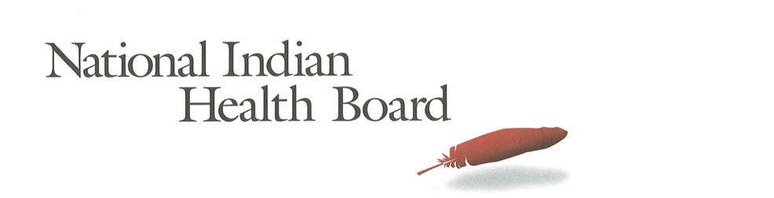

New York

Insurance, Uninsured, and Medicaid: American Indians and Alaska Natives, 2012 and 2017.

This project was supported by a Cooperative Agreement, Grant No. CMS-1MOCMS331623, from the U.S. Department of Health & Human Services, Centers for Medicare & Medicaid Services. The contents provided are solely the responsibility of the authors and do not necessarily represent the official views of HHS or any of its agencies.

New York
Summary Tables: | New York
American Indian and Alaska Native Population 2012 and 2017
2012 | 2017
147,913 | 166,278
American Indian and Alaska Native Uninsured 2012 and 2017
2012 | 2017
16,313 | 9,817
Uninsured Rate 2012 and 2017
2012 | 2017
11% | 6%
Medicaid Enrollment 2012 and 2017
2012 | 2017
54,514 | 69,491
Percent with Medicaid 2012 and 2017
2012 | 2017
37% | 42%

Abstract

This report uses the 2012 to 2017 estimates of the American Community Survey (ACS) to track insurance coverage for American Indians and Alaska Natives including uninsurance rates and Medicaid enrollment. From 2012 to 2017 American Indians and Alaska Natives experienced large decreases in the number uninsured, decreases in the uninsurance rate, and increases in health insurance coverage, particularly Medicaid coverage (enrollment gains).

New York had a 2017 American Indian and Alaska Native Population of 166,000 with 9,800 uninsured and an uninsurance rate of 6%. 2017 Medicaid enrollment was an estimated 69,000 nearly 15,000 more than 2012. New York saw Medicaid coverage increase from 37% of the American Indian and Alaska Native population to 42% in 2017.

Research Note: The American Community Survey (ACS) Coverage Question.

The ACS health insurance question asks the respondent to give a separate answer for each member of the household regarding health insurance coverage. The respondent may choose more than one of the answers to the question about what type of coverage they have.
- Employer Sponsored Insurance (ESI)
- Private, paid by individual also known as “non-Group” coverage
- Medicare
- Medicaid
- Tricare, Health care insurance for military and families
- VA, Veteran’s Administration
- IHS coverage-does respondent have ‘access to IHS’

The ACS estimate of those with ‘access to IHS’ is a reasonable estimate of the number of patients of Indian health programs; including both IHS and Tribally operated programs, not solely IHS operated programs. However, for several states, the estimate does not seem ‘valid’ as it is not close to the likely number of patients who have access to IHS and/or Tribal health programs. It is advisable that one refer to the IHS Active User population when interpreting state health insurance coverage of American Indians and Alaska Natives. The ACS estimate for those with access to IHS in 2017 was 1.4 million nationally compared to the 2017 1.6 million IHS Active User Population (that uses a 3 year time frame to determine users).

Note:
The American Community Survey is an annual survey that provides population estimates, including insurance status estimates. American Indian and Alaska Native are oversampled, but sampling error rate can be very high for smaller populations in some states. These data are from the 2017 survey released in 2018 and accessed using Dataferret on January 18, 2019.

Charts

AI/ANs with Health Insurance
2012-2017 Health Insurance Coverage All AIAN
2012-2017 Health Insurance Coverage: With IHS Access
2012-2017 Health Insurance Coverage: Without IHS Access

AI/ANs Uninsured
2012-2017 Uninsured
2012-2017 Uninsured: With Access to IHS
2012-2017 Uninsured: Without Access to IHS

Number of AI/ANs with Medicaid Coverage
2012-2017 Medicaid Enrollment
2012-2017 Medicaid Enrollment: With Access to IHS
2012-2017 Medicaid Enrollment: Without Access to IHS

Percentage AI/ANs with Medicaid Coverage
2012-2017 Percentage AIANS with Medicaid Coverage
2012-2017 Percentage Medicaid AIANs with Access to IHS
2012-2017 Percentage Medicaid AIANs without Access to IHS

AI/AN Medicaid Coverage, by Access to IHS
2012 Total Medicaid, by Percentage with Access to IHS
2017 Total Medicaid, by Percentage with Access to IHS

AI/ANs Population by Access to IHS
2012 Total Population, by Percentage with Access to IHS
2017 Total Population, by Percentage with Access to IHS

The number of American Indians and Alaska Natives with health insurance coverage increased from 131,000 in 2012 to 156,000 in 2017, a 25,000-person increase. Female coverage increased by 12,000 and males by 12,600.

Health insurance increased by 2,700 for those with access to IHS and 22,000 for those without access to IHS. In New York 9% of American Indians and Alaska Natives have access to IHS. Females saw a greater increase (11,300) than males (10,600) for those without access to IHS, unlike for those with access to IHS (females 800 and males 2,000).

Note: Nationally, 27% of all American Indians and Alaska Natives have access to IHS and 73% do not have access to IHS.

The number of uninsured American Indians and Alaska Natives decreased by 6,000 from 2012 to 2017; from 16,000 to just 10,000. Females saw a decline of 4,600 twice that of males (2,000).

The number of uninsured American Indians and Alaska Natives with access to IHS decreased by 2,600 from 2012 to 2017; from 4,700 to just 2,000. Females made up most of the decrease (1,800 compared to 1,000 for Males). For those without access to IHS the number uninsured declined by 3,800, with males’ decline (1,000) less than the female (2,800) decrease.

Medicaid enrollment increased from 54,000 in 2012 to 69,000 in 2017. This 15,000 overall increase is a welcome result of Medicaid expansion. Males increased by 7,600 and females by 7,300.

Only 100 of the overall Medicaid increase were American Indians and Alaska Natives with access to IHS and 14,800 were American Indians and Alaska Natives without access to IHS. Females without access to IHS increased by 7,200 and males by 7,600. It is actually unusual for male and female increases to be so similar.

In 2012 33% of American Indians and Alaska Natives with access to IHS had Medicaid coverage compared to 37% of those without access to IHS. In 2017 those with IHS access who had Medicaid increased to 34% (a single percentage point increase). In 2017 43% of those without access to IHS had Medicaid coverage (a 6 percentage point gain).

The percentage of American Indians and Alaska Natives with Medicaid coverage rose from 37% in 2012 to 42% in 2017. Males increased from 38% to 42% and females from 36% to 41%.

For those with access to IHS the overall increase in enrollment in Medicaid was from 33% to 34%, males decreased from 38% to 33% and Females increased from 29% to 35%. For those without access to IHS the percentage with Medicaid increased from 37% to 43%; males increased from 38% to 43% and females increased by 5% from 37% to 42%.

In 2017 about 7% of the total American Indian and Alaska Natives with Medicaid had access to IHS down insignificantly from 9% in 2012.

In 2017 9% of the total American Indian and Alaska Native population had access to IHS statistically unchanged from 2012.

